

FPT ACADEMY INTERNATIONAL

FPT – APTECH COMPUTER EDUCATION

Centre Name: ACE-HCMC-2-FPT.

Address: 391A Nam Ky Khoi Nghia St, District 3, Ho Chi Minh City, Viet Nam.



|  |  |  |
| --- | --- | --- |
| Supervisor: | Phạm Thị Lánh | |
| Term: | 1 | |
| Batch No: | T1.2208.E0 | |
| Group No: | 5 | |
| Order: | Full name | Roll No. |
| 1. | Đoàn Văn Thiệu | Student1405215 |
| 2. | Bùi Yến Nhi | Student1405207 |
| 3. | Nguyễn Huy Bình | Student1396949 |

Month 11 Year 2022



This is to certify that

**Mr. ĐOÀN VĂN THIỆU**

**Ms. BÙI YẾN NHI**

**Mr. NGUYỄN HUY BÌNH**

Have successfully Designed & Developed



Submitted by: **Ms. PHAM THI LANH**

Date Of Issue: November, 2022

Authorized Signature:

# Content

**Content** 1

**Acknowledge** 3

**Synopsis** 4

**REVIEW 1** 5

Problem Definition 6

Reader Requirements Specifications 7

Architecture and Design of the project 8

Site map 9

Website Design Layout 10

**I.** **Homepage** 10

**II.** **Sign in** 12

**III.** **Register** 13

**IV.** **World** 14

**V.** **Business** 15

**VI.** **Sports** 16

**VII.** **Books** 18

**VIII.** **Food and Travel** 19

**IX.** **Contact us** 20

**X.** **Content detail** 21

**XI.** **Feedback** 22

Task Sheet 23

**REVIEW 2** 24

WEBSITE USER INTERFACE 25

**I.** **Homepage** 25

**II.** **Sign in** 28

**III.** **Register** 29

**IV.** **World** 30

**V.** **Business** 33

**VI.** **Sports** 35

**VII.** **Books** 39

**VIII.** **Food and Travel** 41

**IX.** **Contact us** 43

**X.** **Content detail** 44

**XI.** **Feedback** 46

**XII.** **About** 47

Task Sheet 48

Testing document 50

Final checklist 51

**Acknowledge**

As we understand that the eProject is a step-by-step learning environment that closely simulates the classroom and Lab based learning environment into actual implementation. It is a project implementation at your fingertips!! An electronic, live juncture on the machine that allows you to.

* Practice step by step i.e. laddered approach.
* Build a larger more robust application.
* Usage of certain utilities in applications designed by user.
* Single program to unified code leading to a complete application.
* Learn implementation of concepts in a phased manner.
* Enhance skills and add value.
* Work on real life projects.
* Give a real life scenario and help to create applications more complicated and useful.
* Mentoring through email support.

This project consumed huge amount of work and dedication. Still, implementation would not have been possible if we did not have a support of many individuals. Therefore we would like to extend our sincere gratitude to all of them.

First of all we are thankful to Ms Pham Thi Lanh for providing necessary guidance concerning projects implementation as well as her provision of expertise. Without her superior knowledge and experience, the Project could not have been successful. We also would like to express our sincere thanks towards the members of the team who devoted their time and knowledge in the implementation of this project, and also to the other students for their enthusiastic support during this time.

Finally, We also thank you so much for your information and the “demo” project from India APTECH to help us get more reality experience in this project. Beside several mistakes we had made in the project, we hope to have more opportunities to widen our knowledge in the web developing world.

Your Sincerely,

Team Group 05.

**Synopsis**

* The Objective of this program we aim is to give a sample project to work on real life projects. These applications help us build a larger, more robust application.
* The objective is not to teach us HTML/JavaScript but to provide us with a real life scenario and help us create basic applications using the tools.
* Hence, we can revise the chapters before we start with the project.
* This project is meant for students who have completed the module of HTML5.
* These programs should be done in the Lab sessions with assistance of the faculty if required.
* The website (in this project) is a tool that help the company to access the international market and gain more and more new customers.
* It is very essential that a student has a clear understanding of the subject.

**REVIEW 1**

## Problem Definition

DNBC is an established name News and Reporting. They have their network of reporters across the world.

They collect and send all news articles to the main office in London.

Main Office then prepares the news and publish it in newspaper in respective segments.

To make news available in faster to the readers and subscribers, now company is planning to launch a website. This will help in bringing information and news faster and also readers can search and read news from any location.

The website which they demand is suppose to provide user friendly environment and navigation. The important menu must be stated in the top section of the webpage. Also a decent look out and color combination is expected.

The website is to be developed for the Windows Platform using HTML5, JavaScript and Geolocation. The site should work well in all leading browsers including Chrome, IE, Firefox etc.

Having read the project specifications, our team members realize that there are problems and difficulties which may interfere the users’ experience. In order to make the most precise decision and look for the best solution to tackle this, each developer has to consider the following querries thoroughly:

1. How to build a layout for an online newspaper website?
2. How many categories is enough?
3. How much content is displayed on a page when they are grouped into categories?
4. What information should be displayed on the homepage?
5. How can users interact with the site?

## Reader Requirements Specifications

|  |
| --- |
| USER: |
| Input:   * Reader send questions/requests to the company |
| Process:   * Server process reader’s request |
| Output:   * Reply to the consumer’s requests/questions |

|  |
| --- |
| WEBMASTER: |
| Input:  ● Control website database, input product information,… |
| Process:  ● Analyse website |
| Output:  ● Website interface, images, forms, …  ● Giving interaction |

|  |
| --- |
| HARDWARE / SOFTWARE REQUIREMENT: |
| Software:  • Notepad/HTML editor  • Dreamweaver  • IE 5.0/ Netscape 6.0 |
| Hardware:  • A minimum computer system that will help you access all the tools in the courses is a Pentium 166 or better  • 64 Megabytes of RAM or better |

## Architecture and Design of the project

Clients

Server

HTML, CSS, Javascript, Jquery, Bootstrap, Angularjs

Windows platform device

## Site map

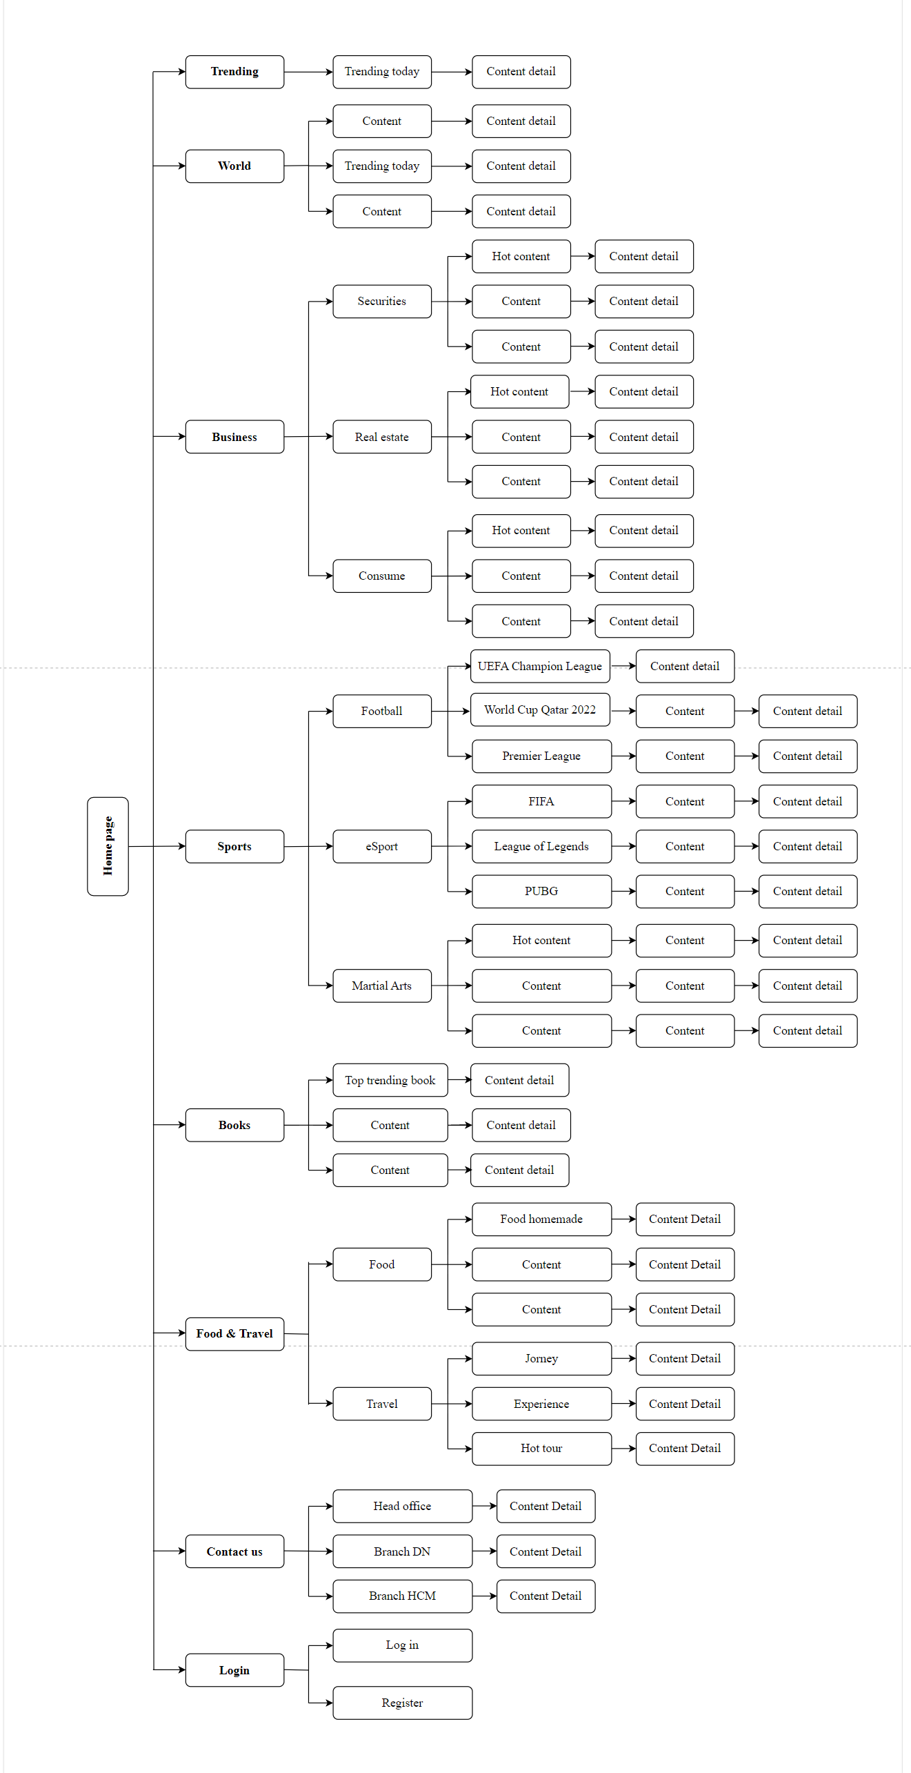

## Website Design Layout

1. **Homepage**

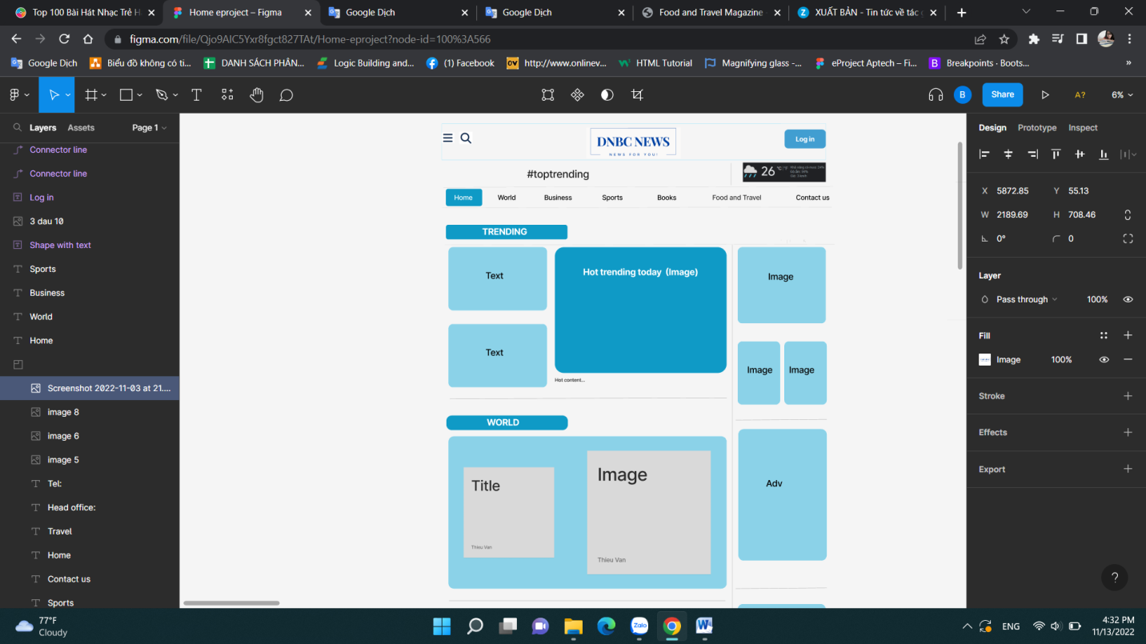

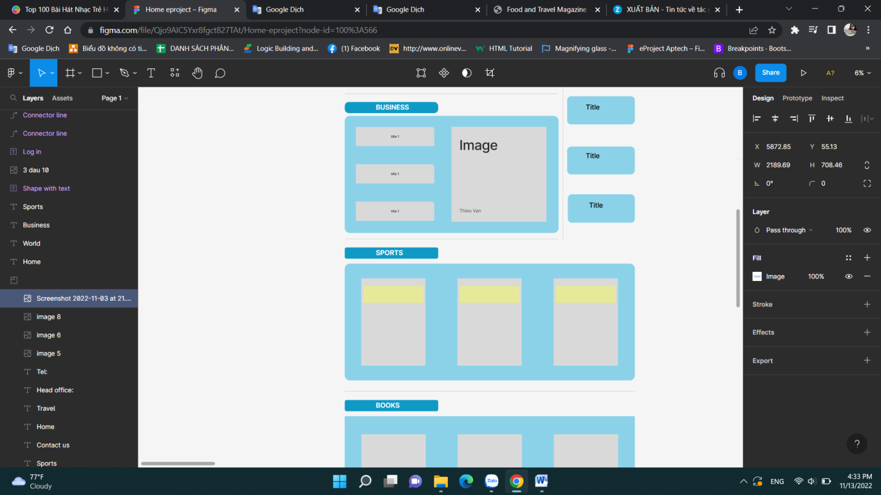

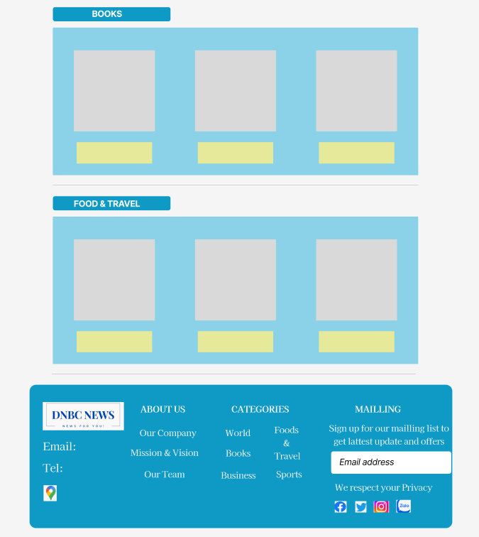

**Description:** This is the homepage of DNBC NEWS, the top of which is the header including menu, search, logo and log in, followed by the navigation bar. The main part of the homepage includes: trending and related news. The footer of a home page also includes links to other pages of information or contact information.

1. **Sign in**

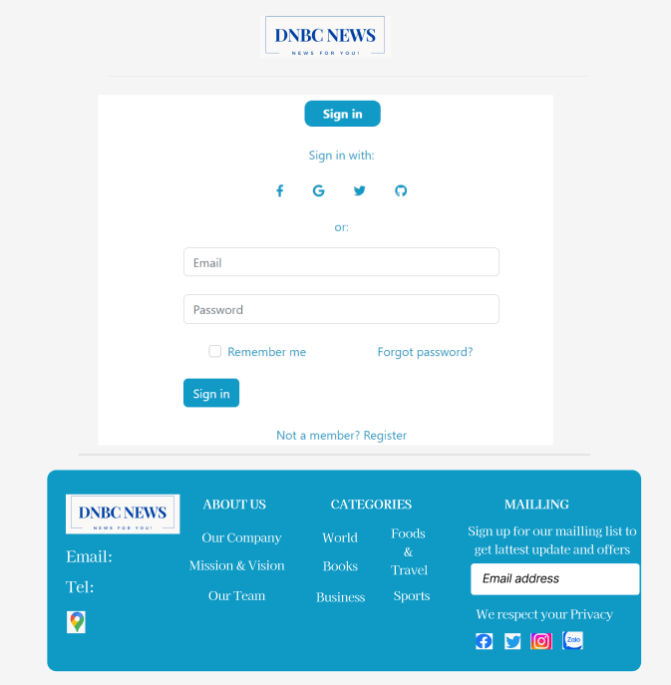

**Description:** When the user clicks Log in on the header, it will lead to the login page. This form requires the user to enter an email address, press continue to enter the password. After clicking the login button, the user will be redirected to the homepage. Also users can login with Google, Facebook or Apple.

1. **Register**

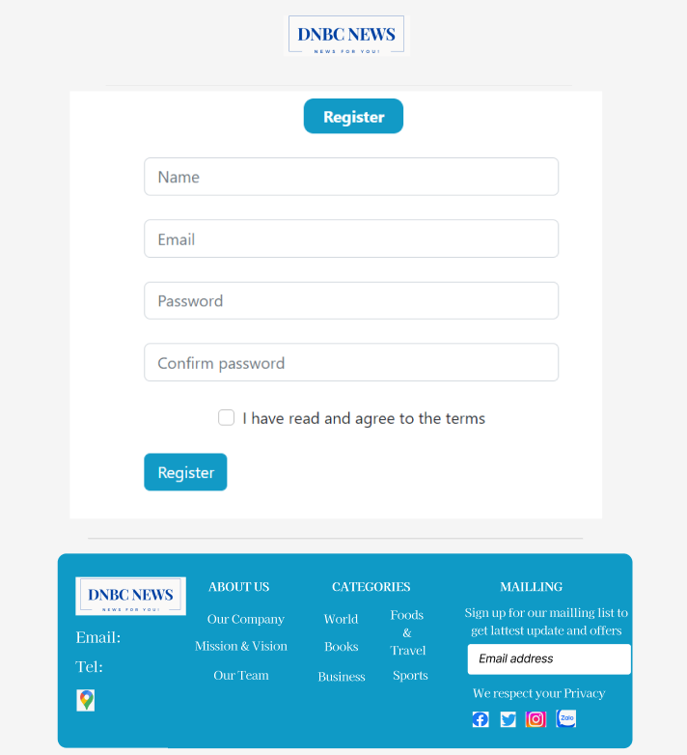

**Description:** If the user hasn’t created an account, he/she can click to Create new account in the sign in page and it will lead to this sign up page. This sign up form requires the user to enter 4 fields: first name, last name, email and password. After clicking the sign up button the user will be redirected to the homepage.

1. **World**

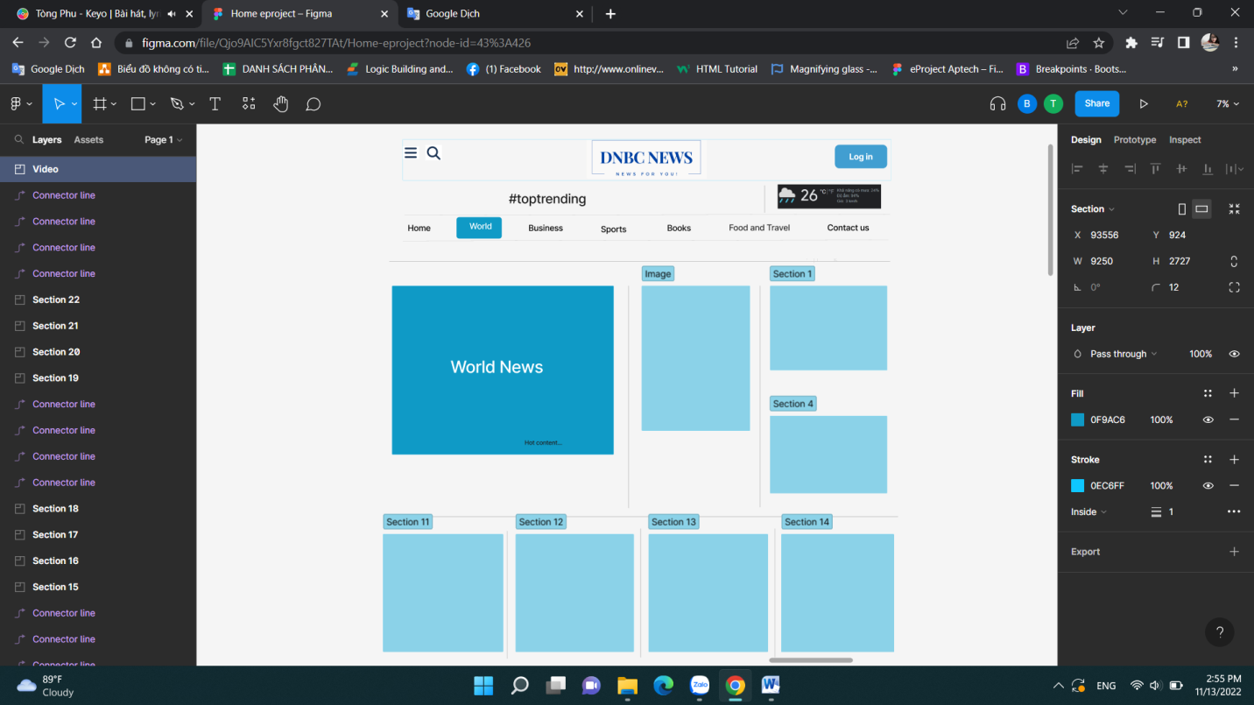

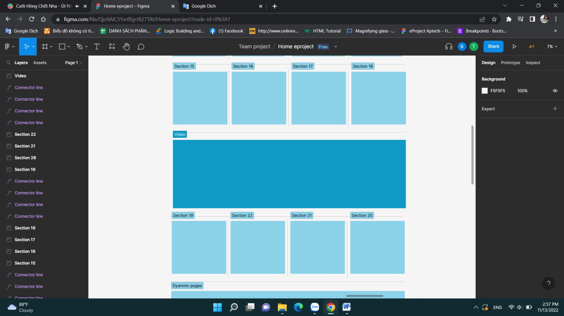

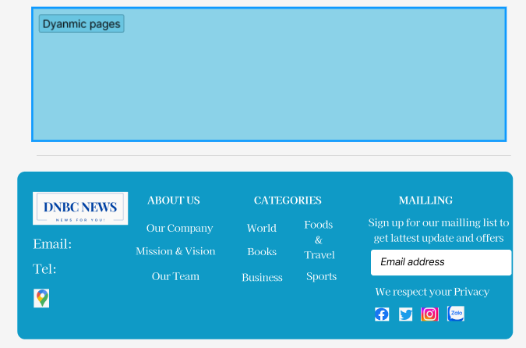

**Description:** When the user clicks on the World tag in the navigation, it will lead to this page. The main section of this page includes highlights of the day and other world news.

1. 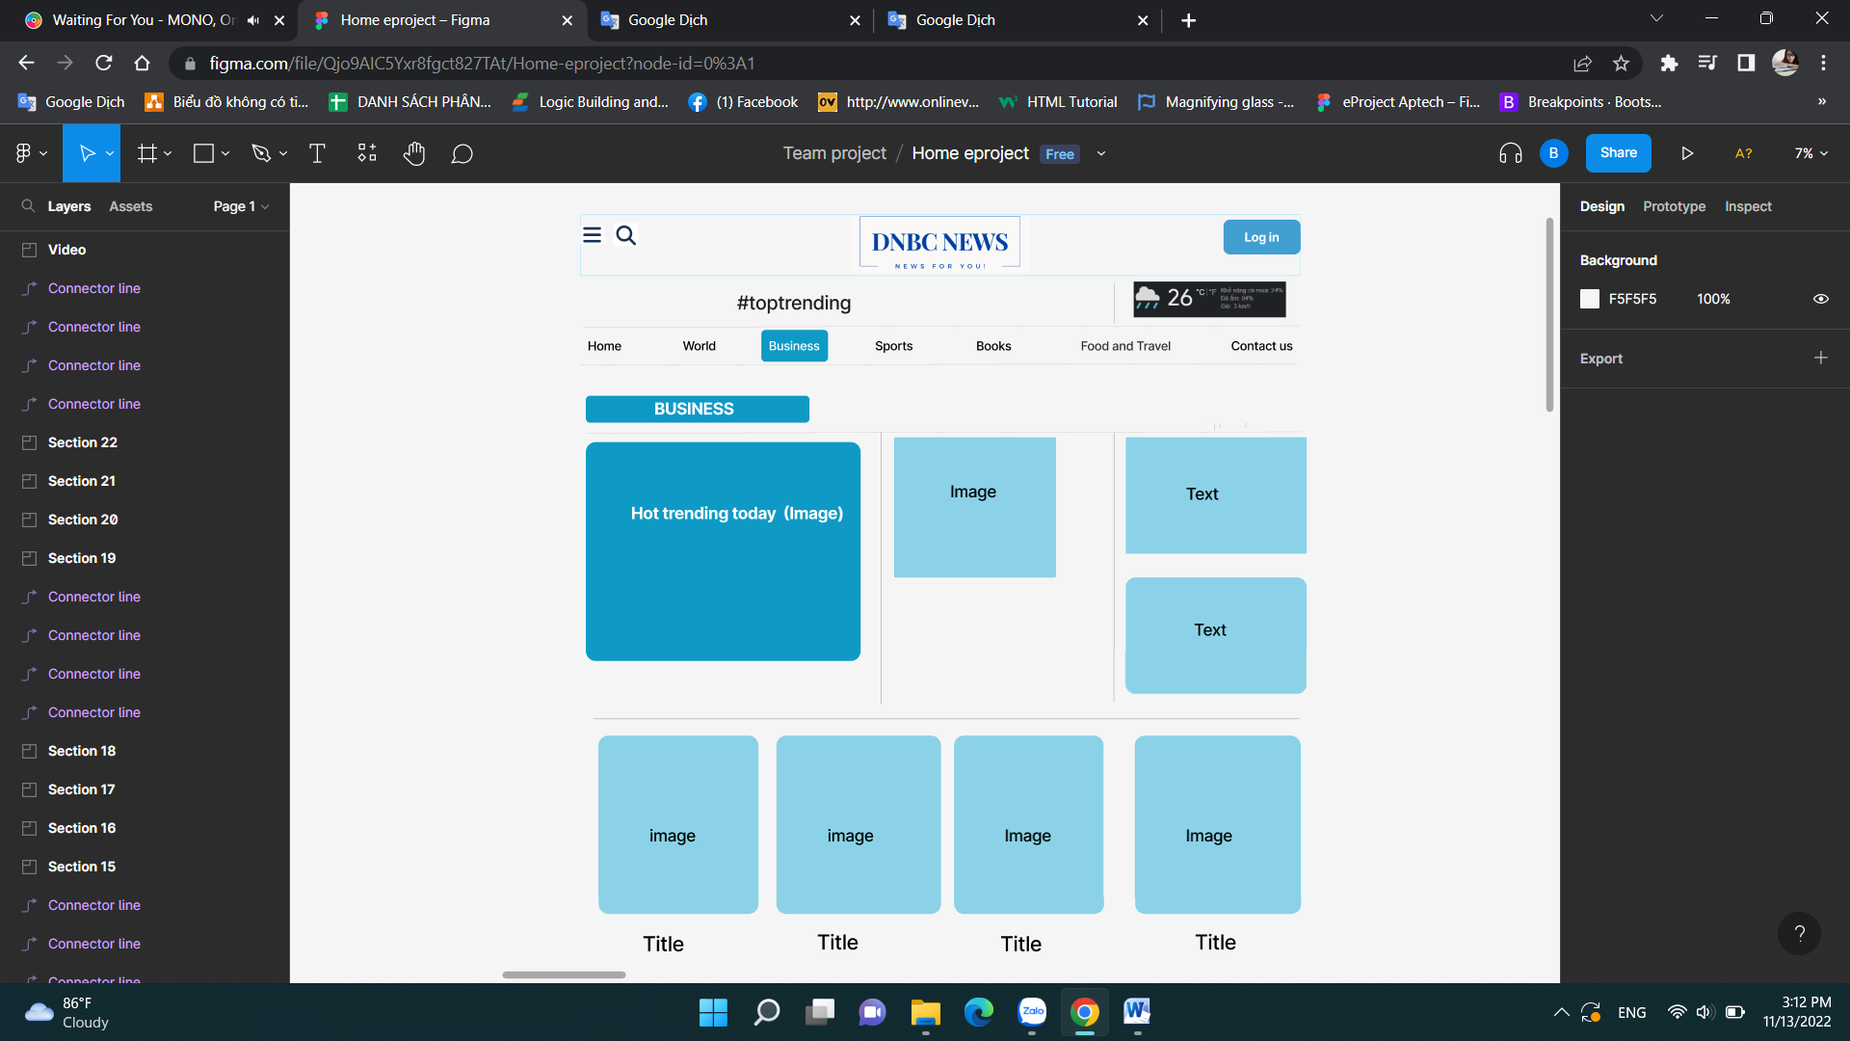**Business**

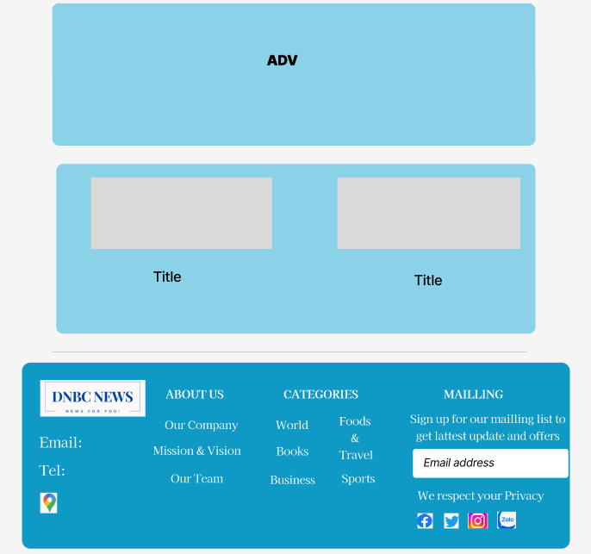

**Description:** When the user clicks on the Business tab in the navigation, it will lead to this page. The main part of this page includes the economic highlights of the day and economic activities around the production and distribution of goods and services to meet the needs of the people.

1. **Sports**

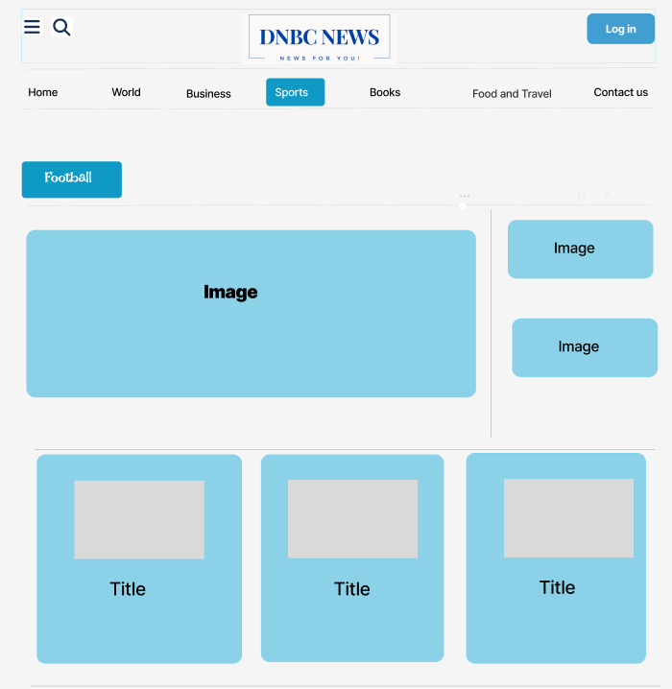

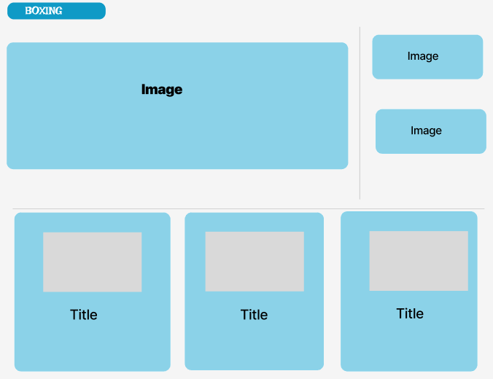

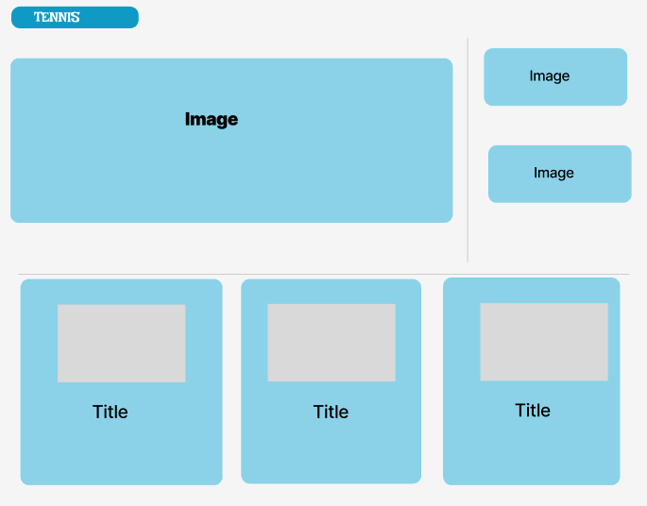

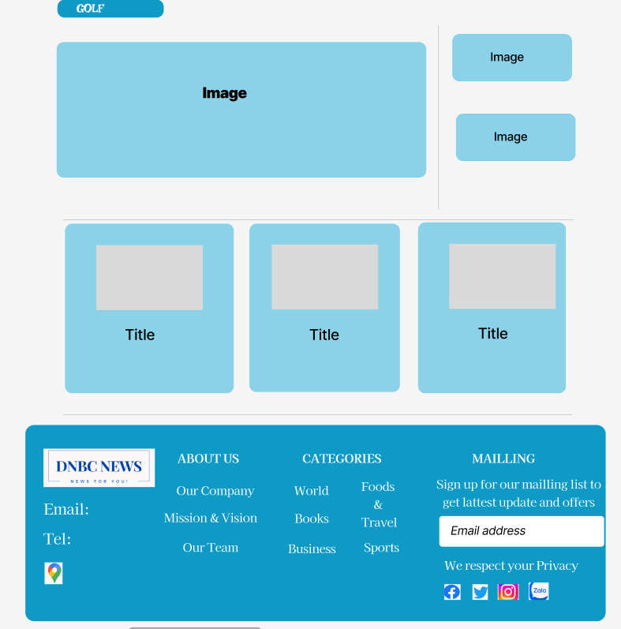

**Description:** When the user clicks on the Sports tab in the navigation, it leads to this page. This page will be updated sports news, fixtures, results.... In addition, we can separately view news about other sports such as soccer, volleyball, martial arts, e-sports, and golf by click on the keywords below the navigation bar.

1. **Books**

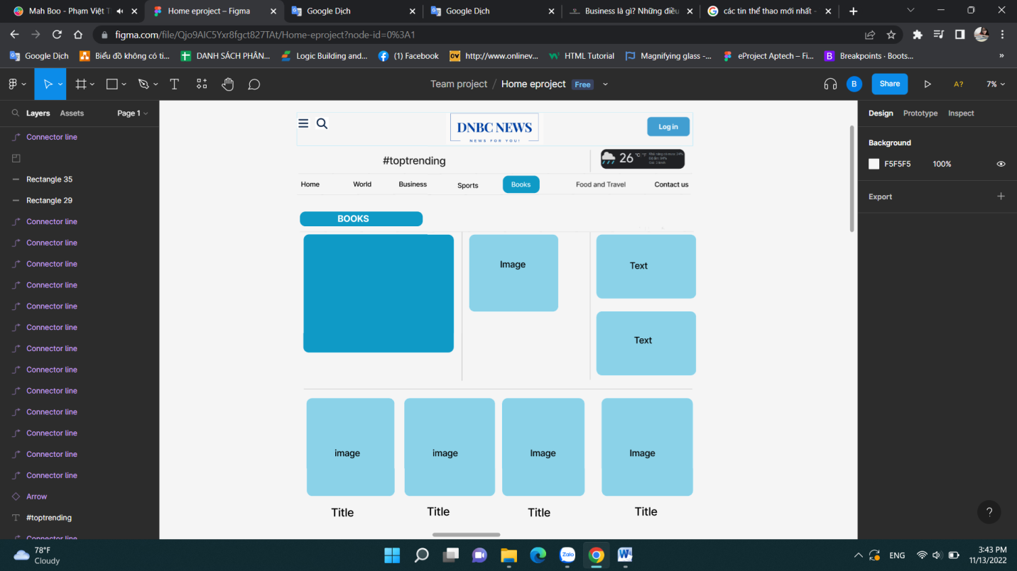

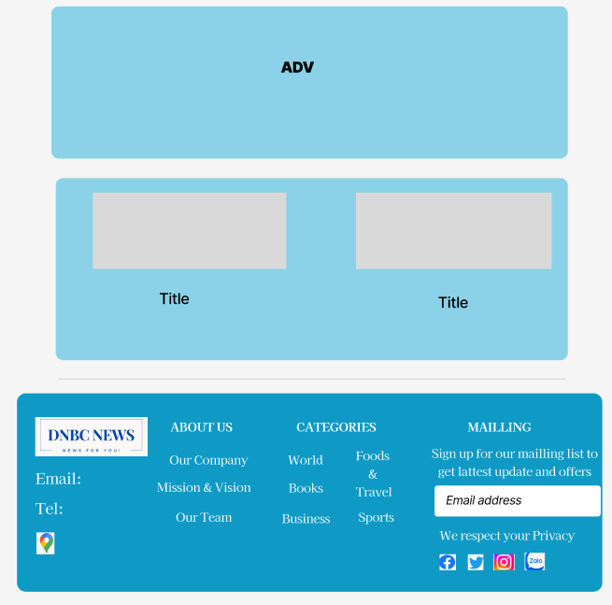

**Description:** When the user clicks on the Books tab in the navigation, it will lead to this page. In this page will update news about the author, interesting books, how to read books,...

1. **Food and Travel**

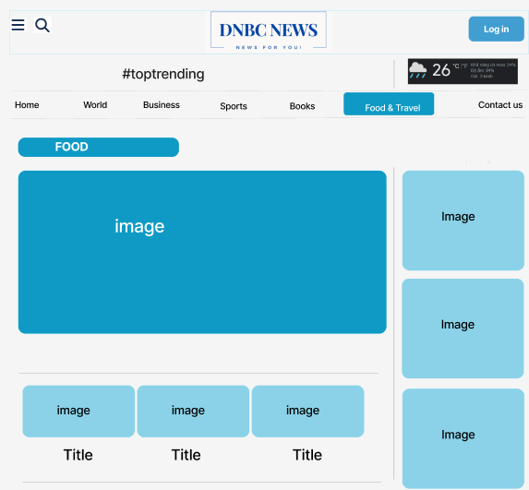

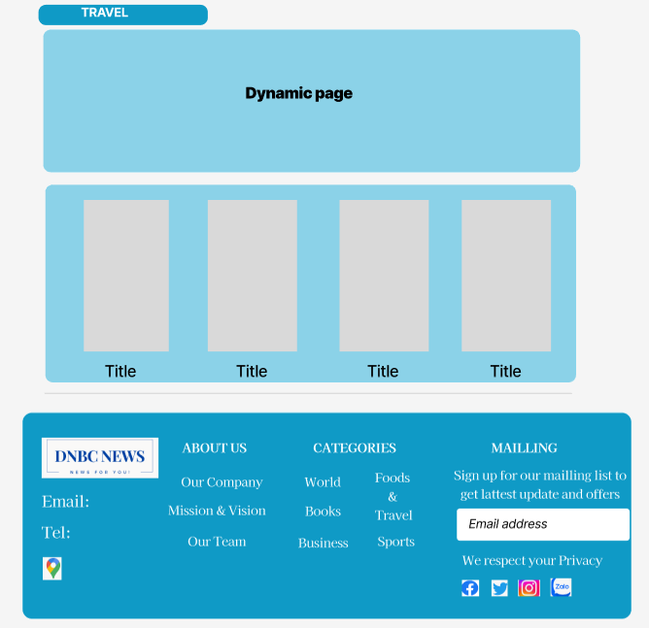

**Description:** When the user clicks on the Food & Travel tag in the navigation, it will lead to this page. In this page will update outstanding news about 2 areas: food and travel.

1. **Contact us**

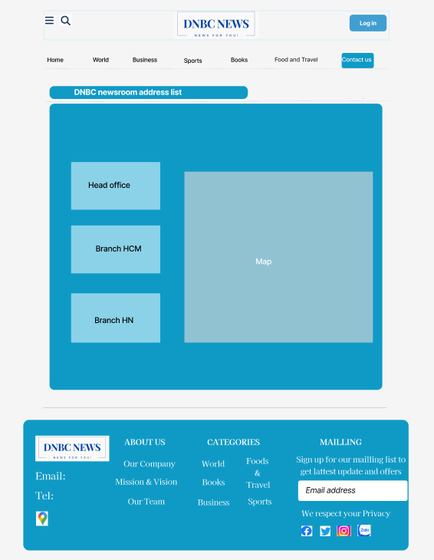

**Description:** When the user clicks on the Contact us tag in the navigation, it will lead to this page. In this page will update the head office, branch. When clicking on the head office or branch, the map will be updated.

1. **Content detail**

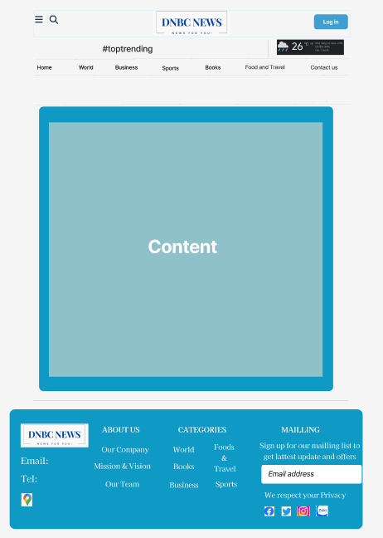

**Description:** When the user clicks on the content or image in the tags it will lead to this page. In this page will update detailed content and allow users to comment on that topic.

1. 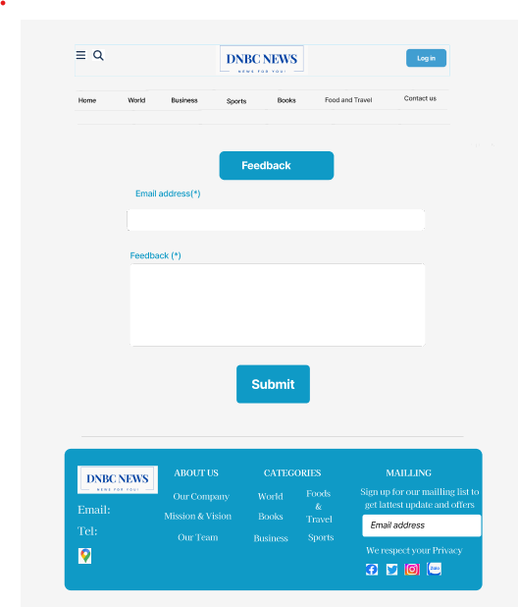**Feedback**

**Description:**The final section is the Submit Information form to submit their information and thoughts to DNBC NEWS**.**

1. 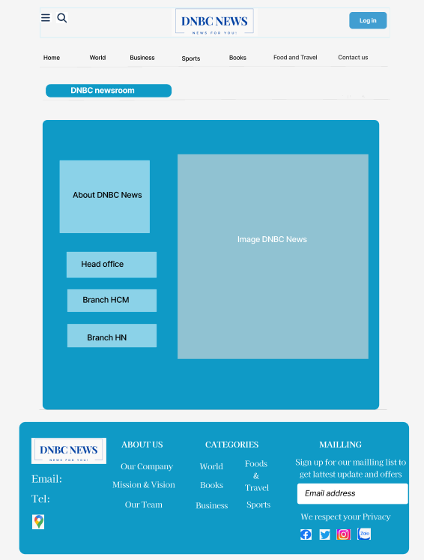**About**

### Task Sheet

|  |  |  |  |  |  |  |
| --- | --- | --- | --- | --- | --- | --- |
| **Project Ref No.** | **Project Title – Ask Me Mobile** | **Activity Plan Prepared by** | **Date of preparation of Activity Plan** | | | |
| **Task** | **Actual Start Date** | **Actual Days** | **Teammate Names** | **Status** |
| Brainstorming ideas for layouts and Project Object | | Thiệu, Nhi, Bình | 02/11/2022 | 1 days | Thiệu, Nhi, Bình | Completed |
| Draw site maps and architecture design | | Thiệu, Nhi | 02/11/2022 | 2 days | Thiệu, Nhi | Completed |
| Wire framing general page layout | | Thiệu, Nhi, Bình | 05/11/2022 | 3 days | Thiệu, Nhi, Bình | Completed |
| Collect static assets (pictures, mp3, documentation,…) | | Thiệu, Nhi, Bình | 05/11/2022 | 5 days | Thiệu, Nhi, Bình | Completed |

**REVIEW 2**

## WEBSITE USER INTERFACE

1. **Homepage**

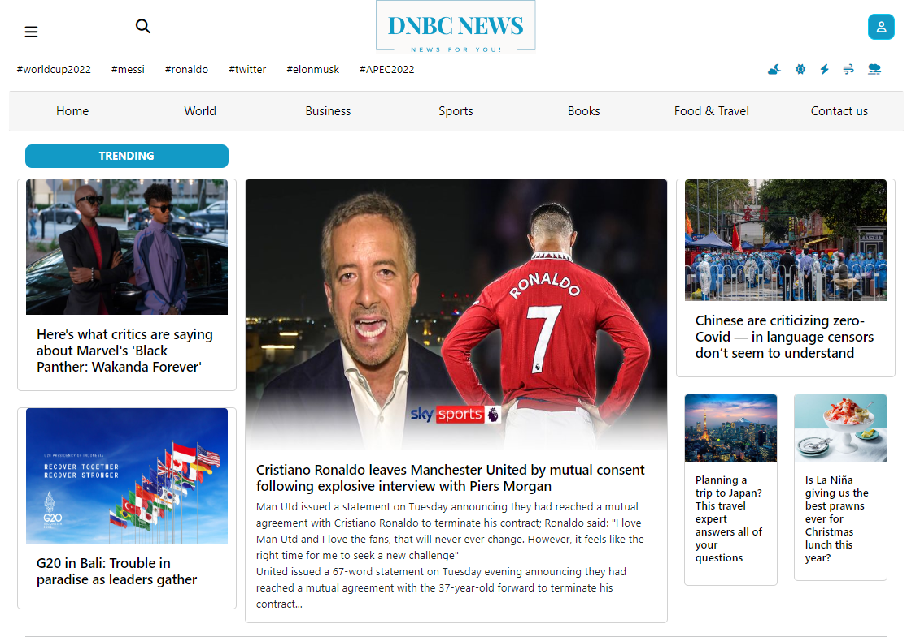

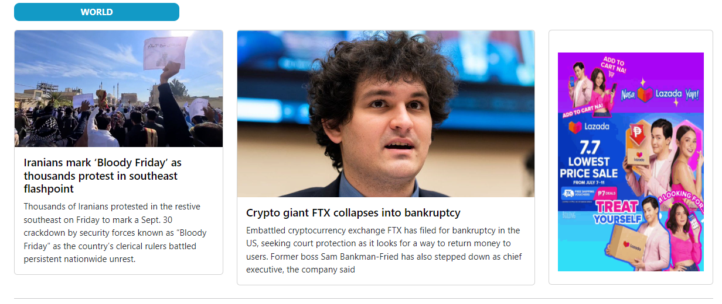

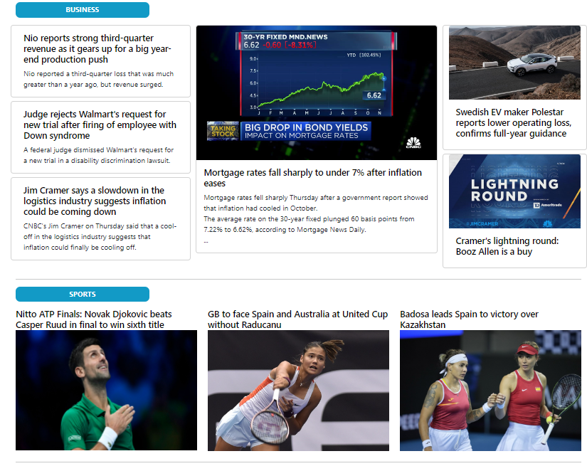

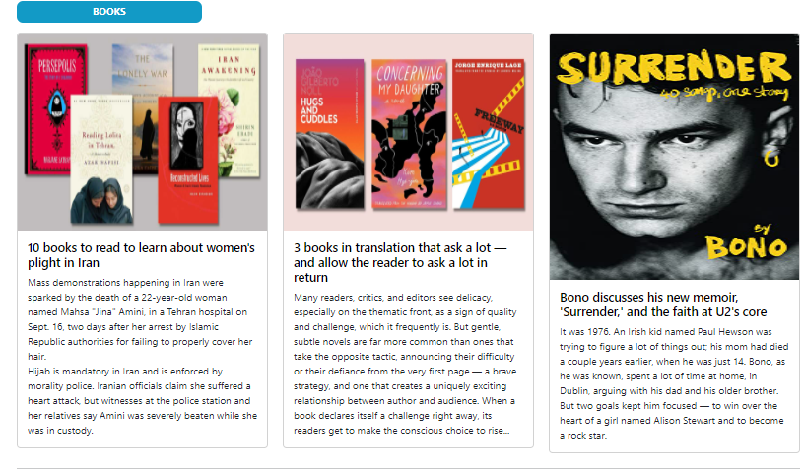

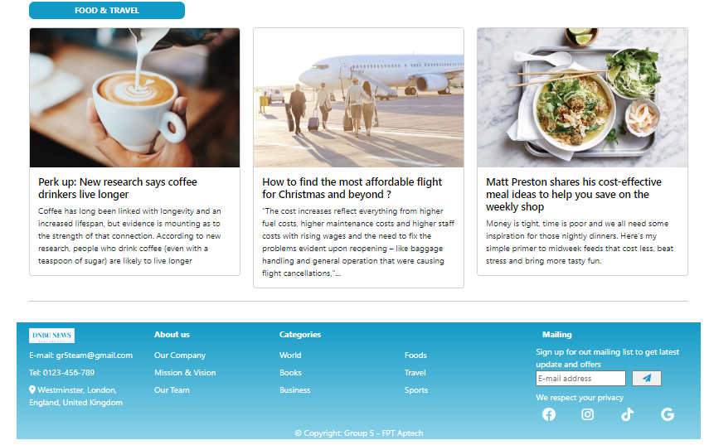

1. **Sign in**

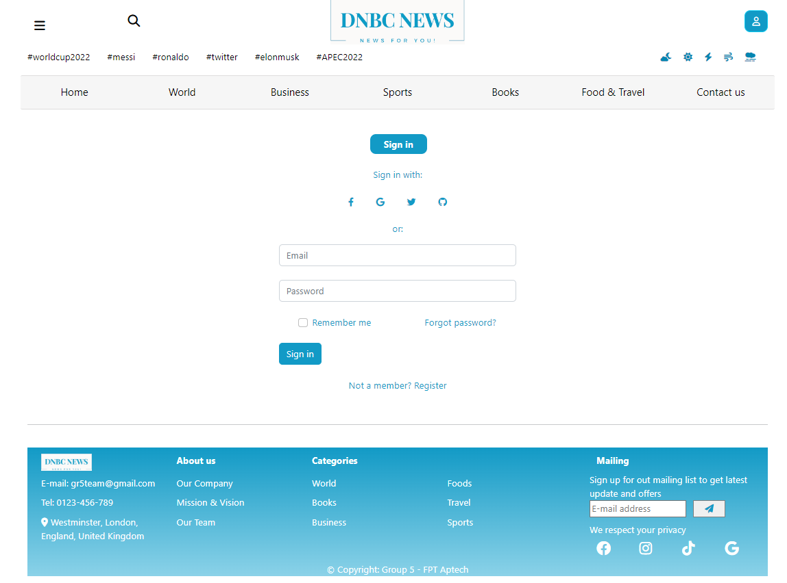

1. **Register**

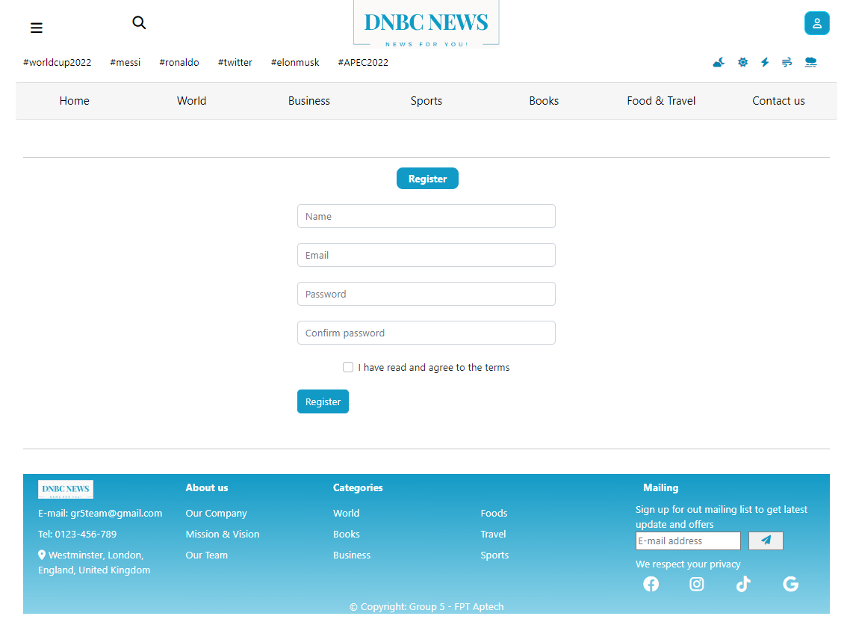

1. **World**

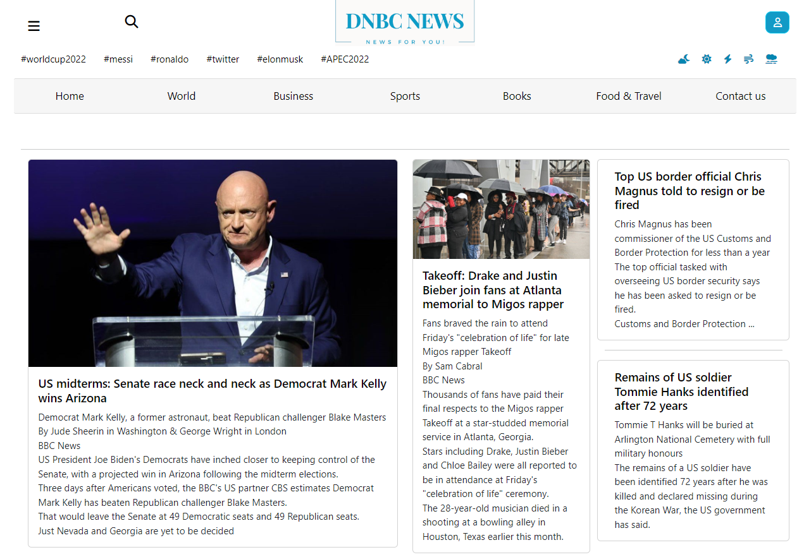

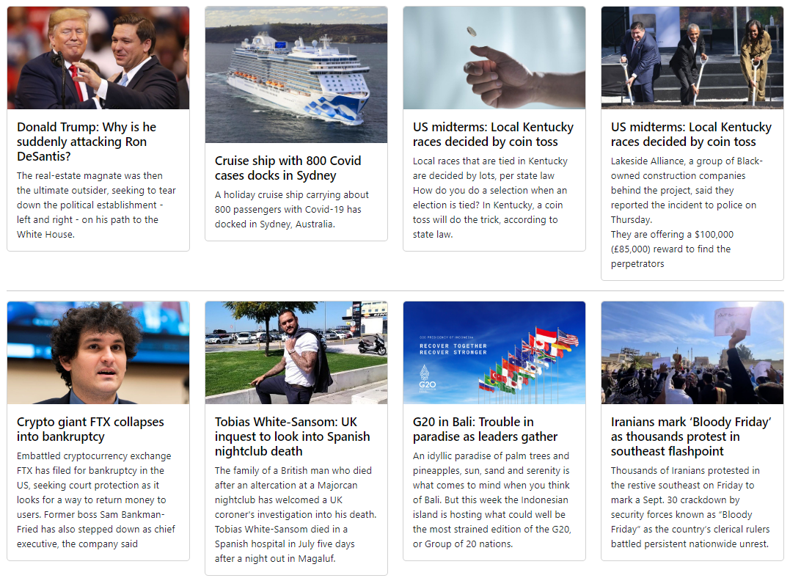

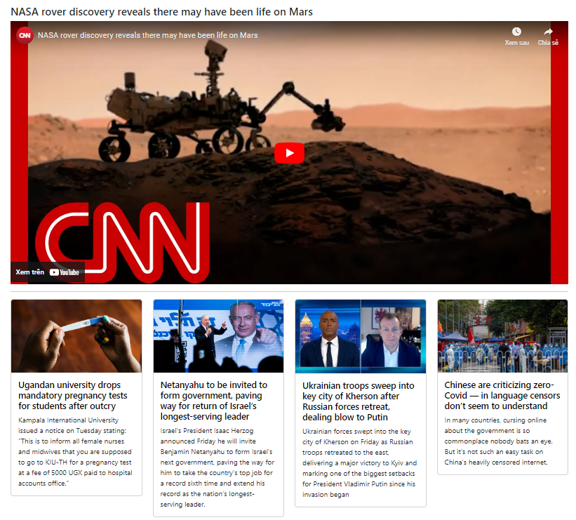

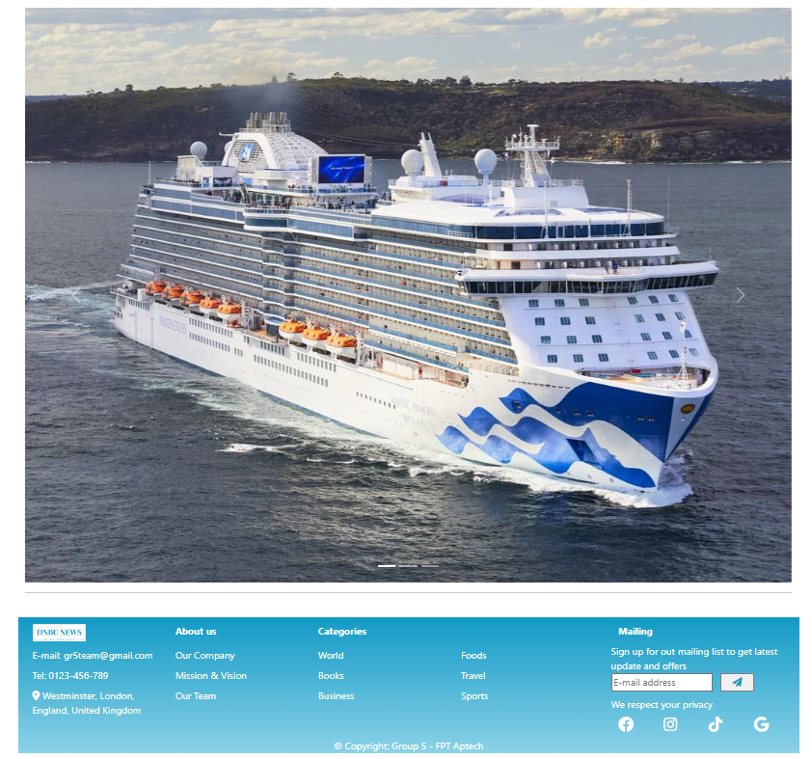

1. **Business**

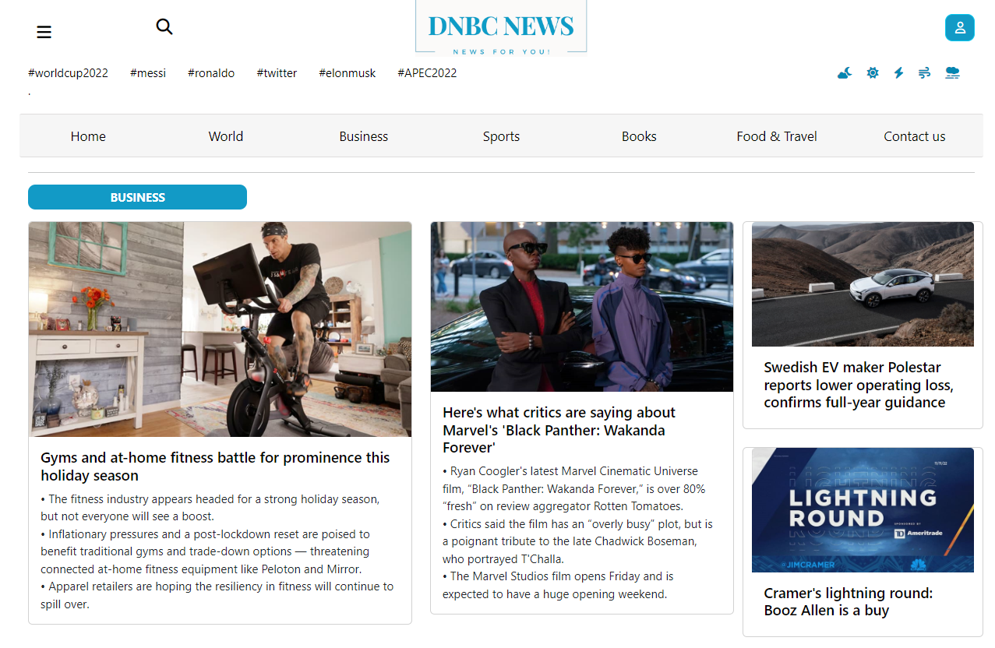

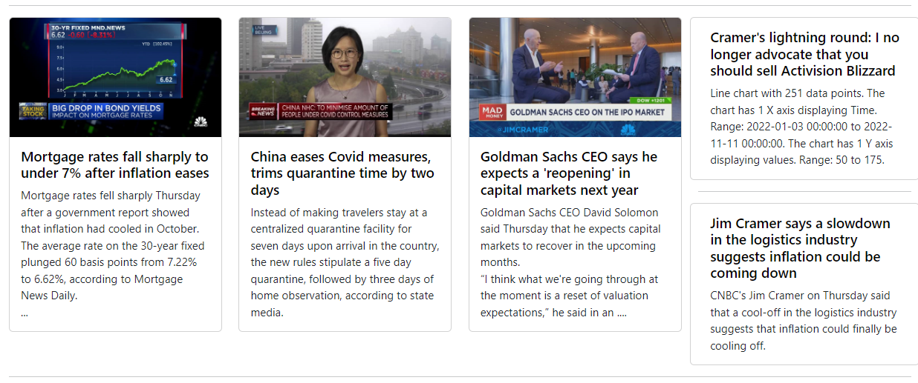

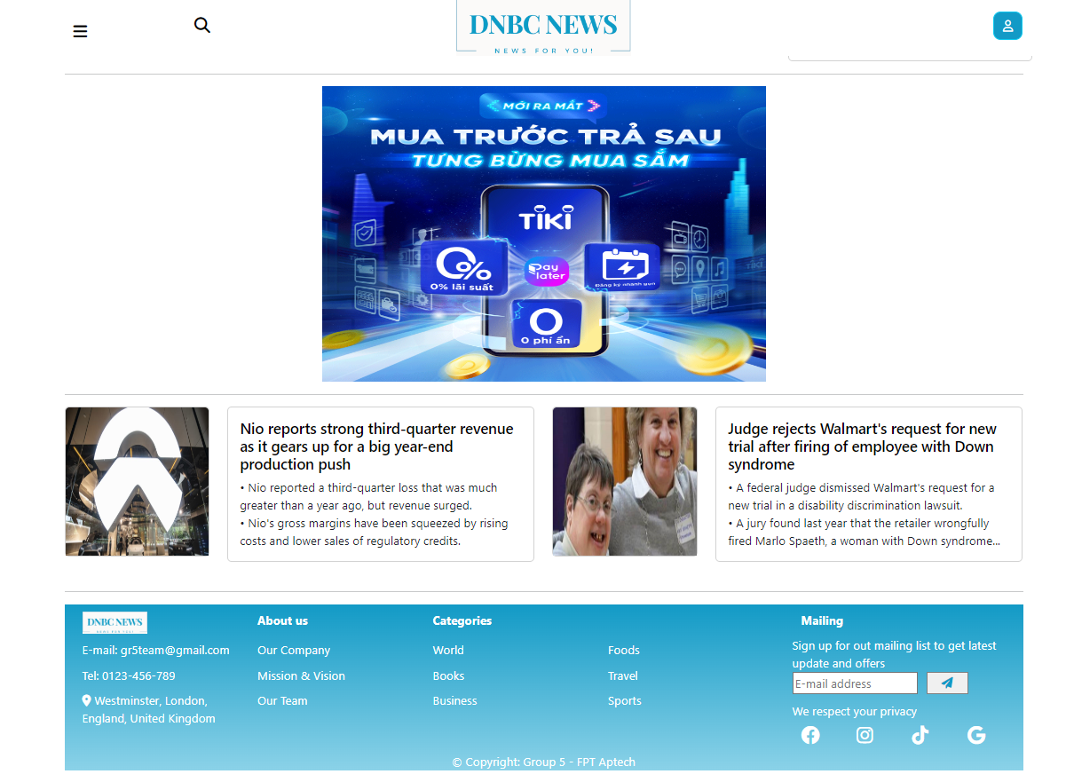

1. **Sports**

****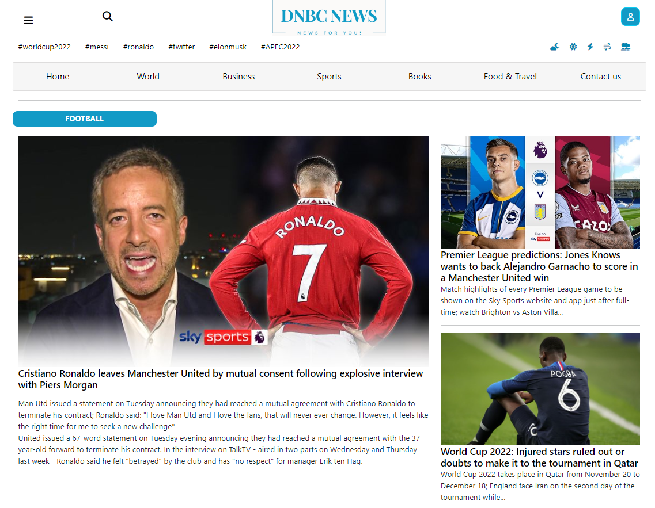



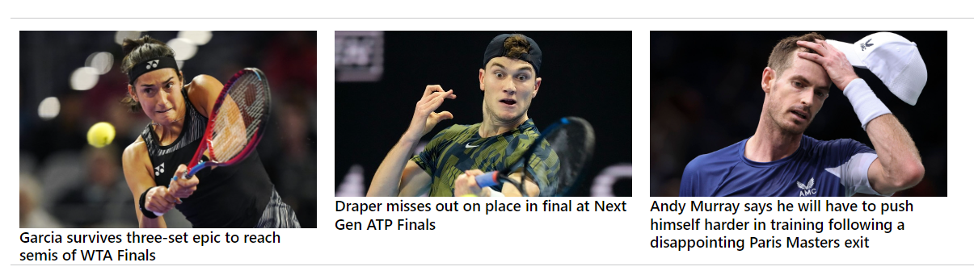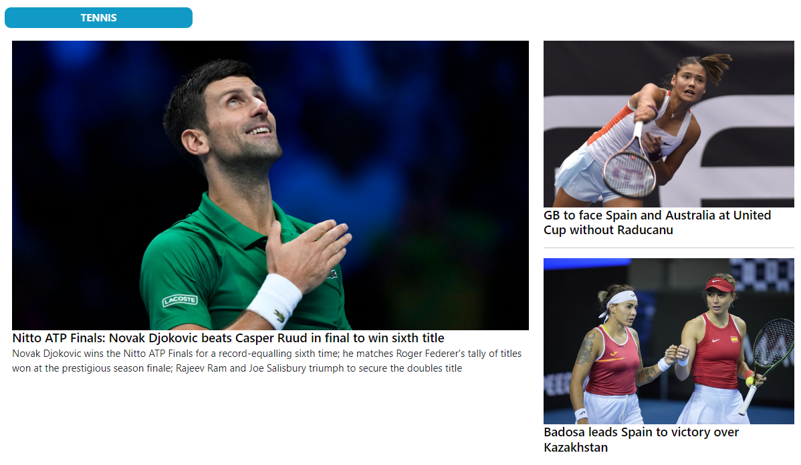

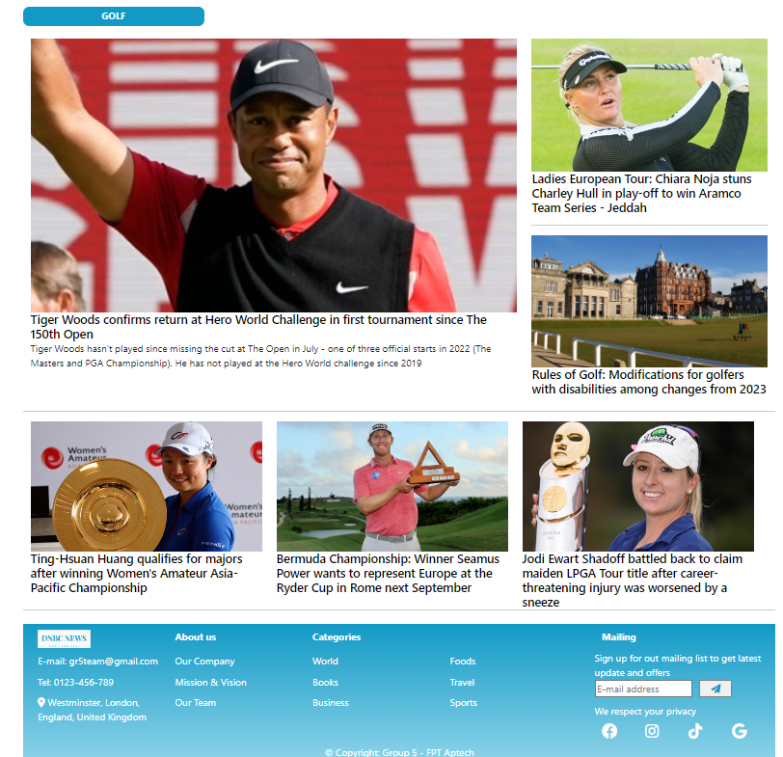

1. **Books**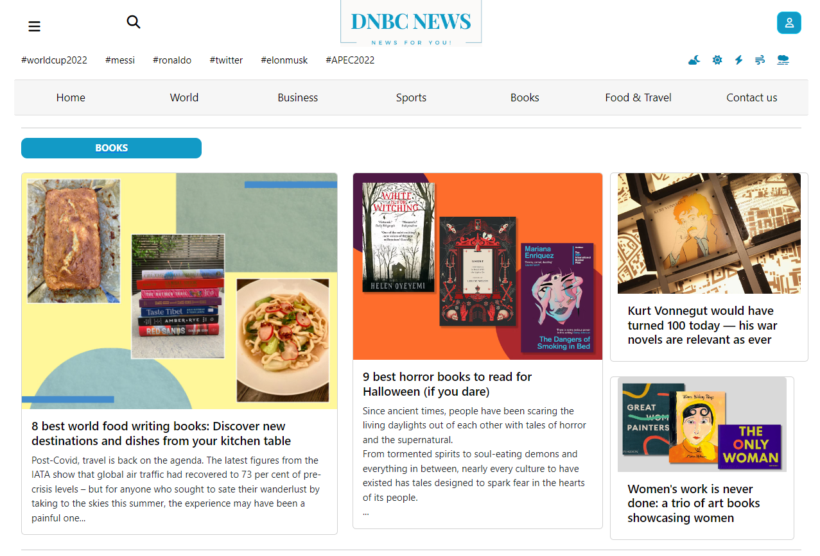





1. **Food and Travel**

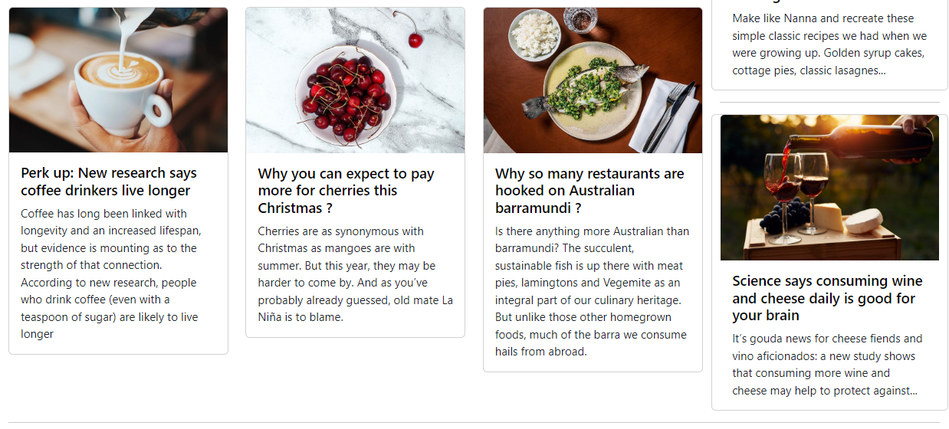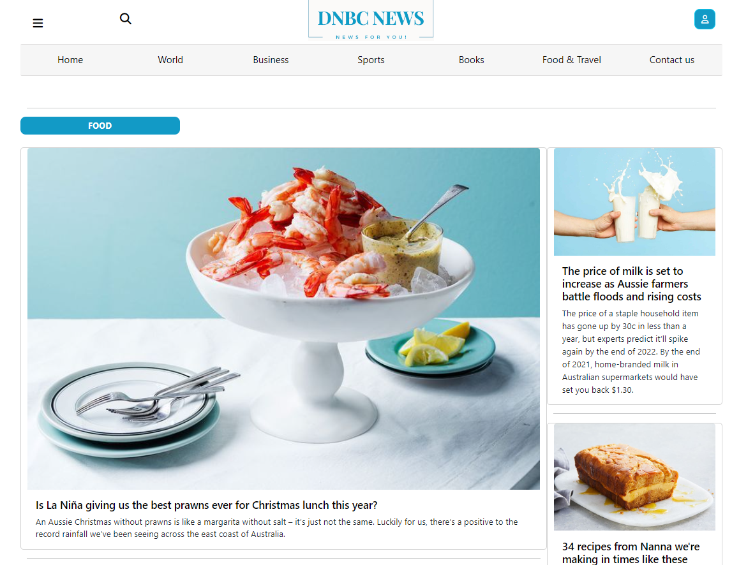

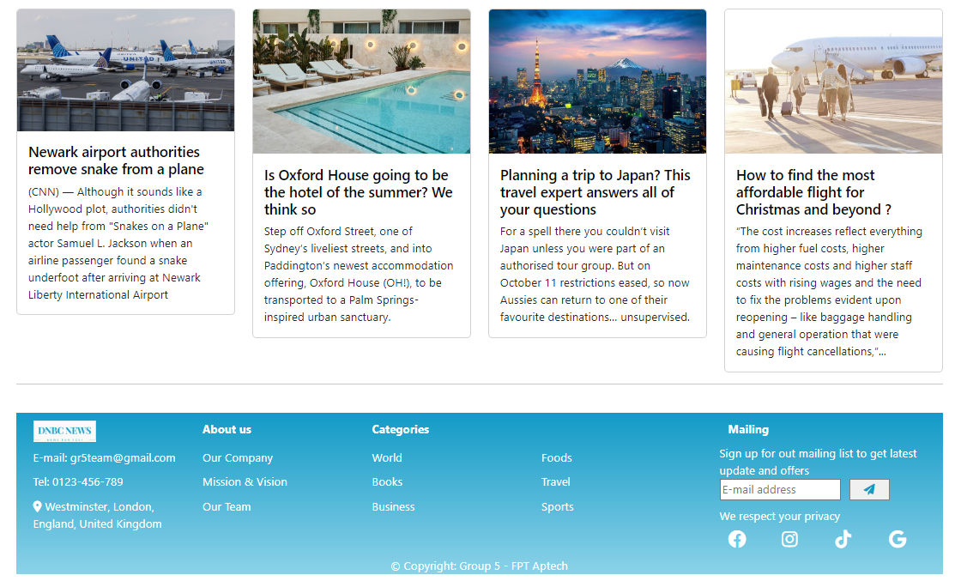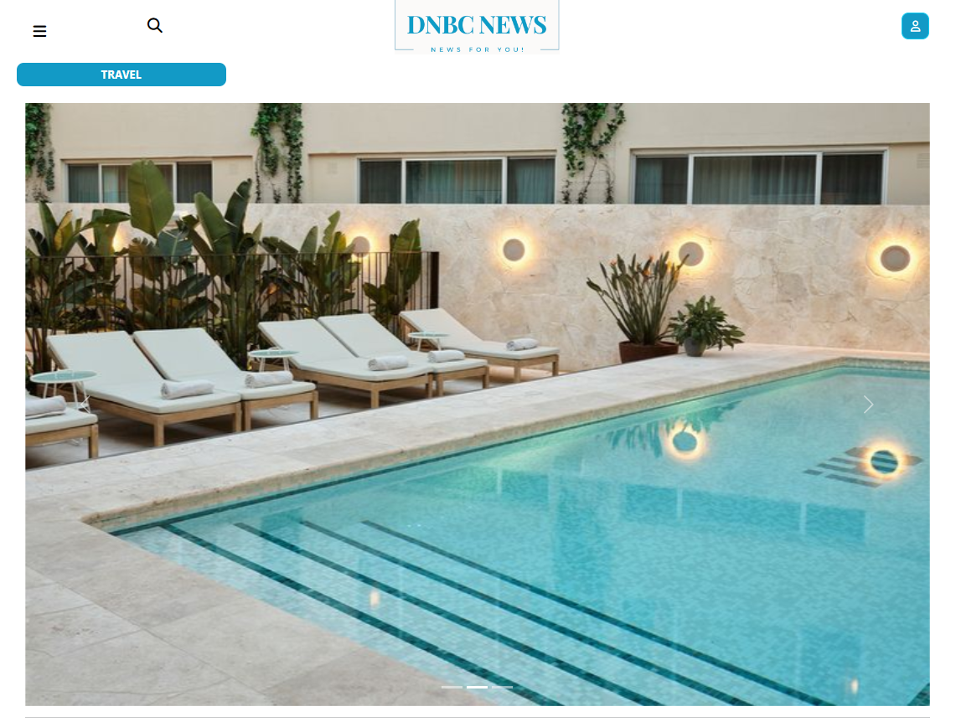

1. **Contact us**

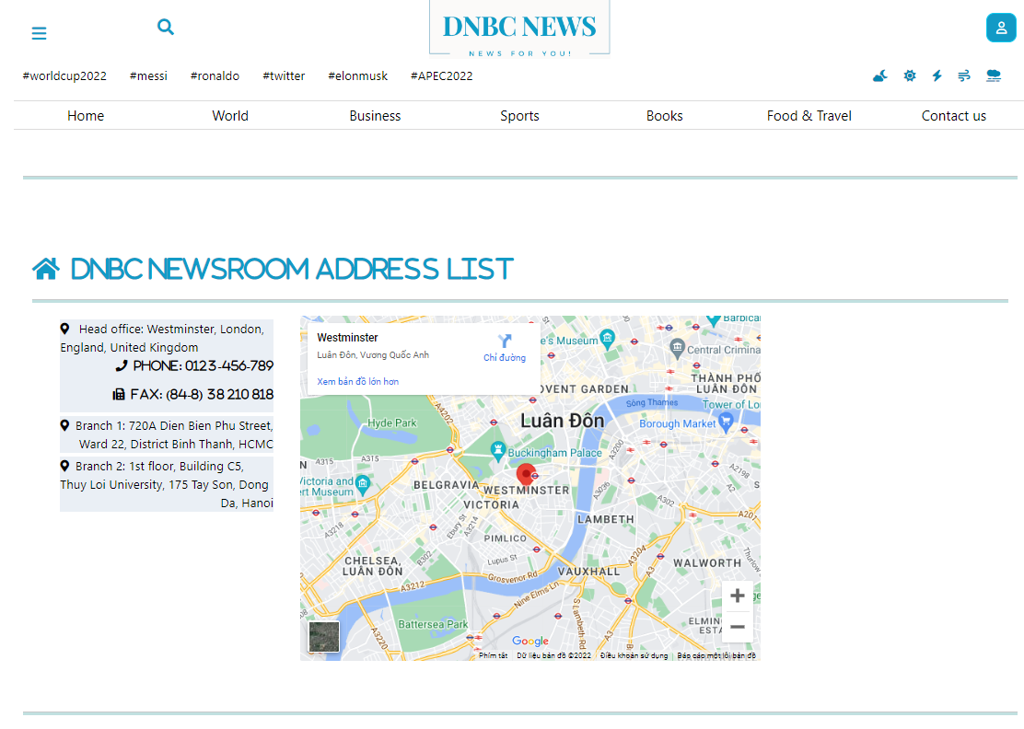

1. 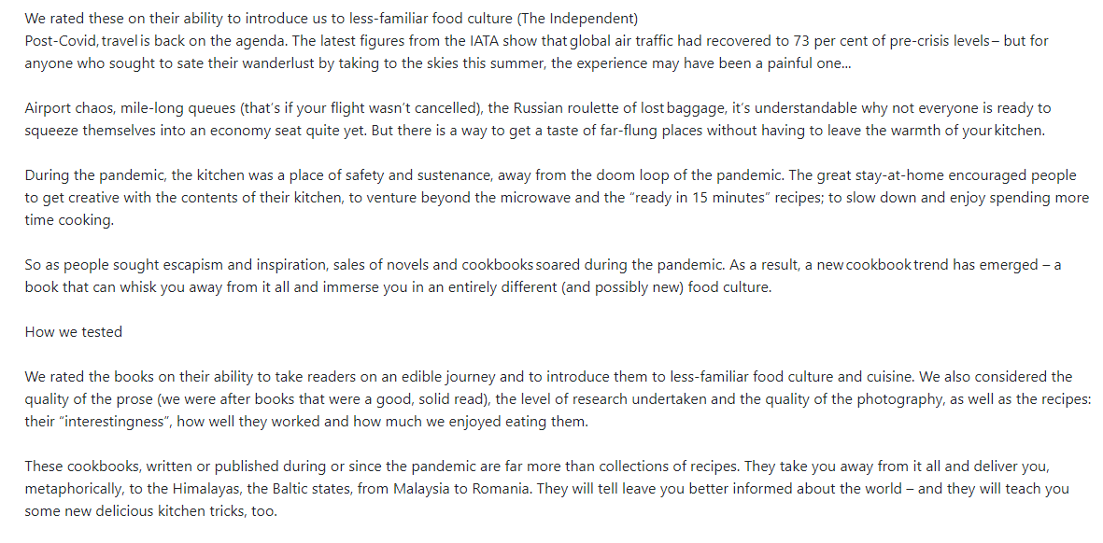**Content detail**

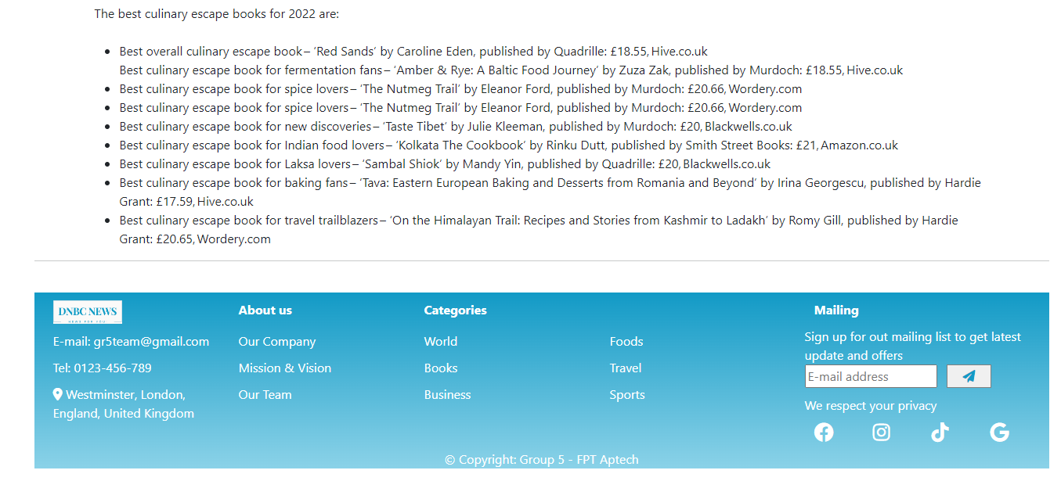

1. **Feedback**

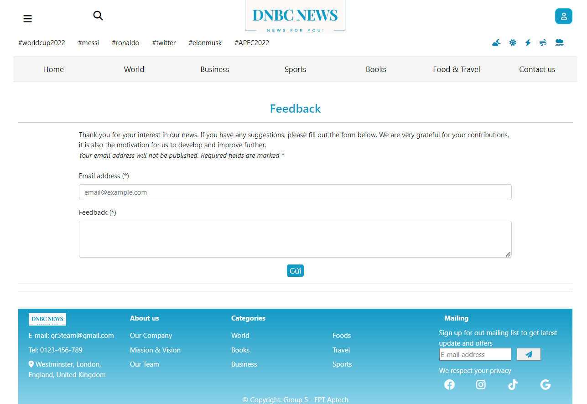

1. **About**

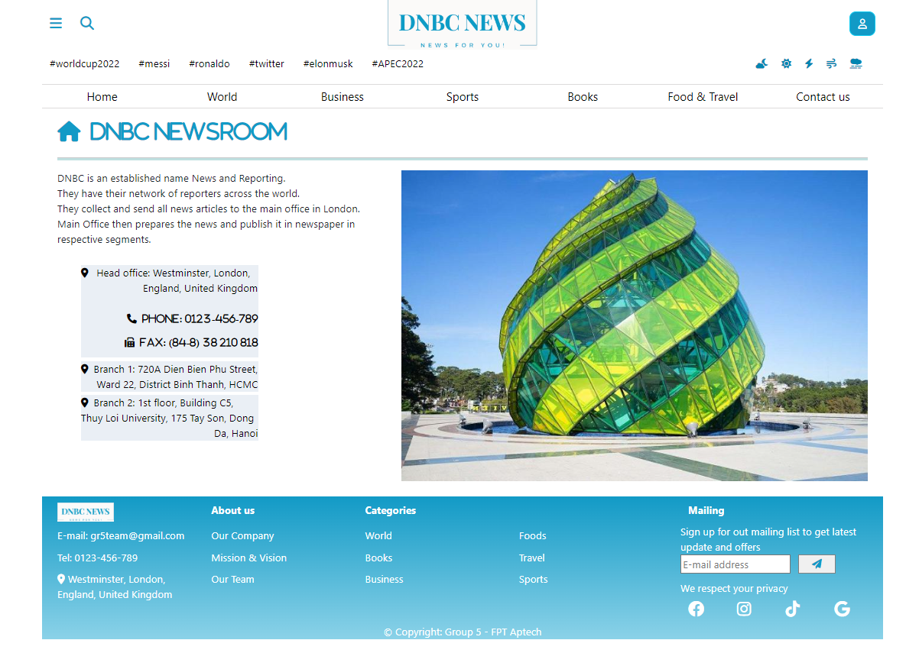

### Task Sheet

|  |  |  |  |  |  |  |
| --- | --- | --- | --- | --- | --- | --- |
| **Project Ref No.** | **Project Title – Ask Me Mobile** | **Activity Plan Prepared by** | **Date of preparation of Activity Plan** | | | |
| **Task** | **Actual Start Date** | **Actual Days** | **Teammate Names** | **Status** |
| Brainstorming ideas for layouts and Project Object | | Thiệu, Nhi, Bình | 02/11/2022 | 1 days | Thiệu, Nhi, Bình | Completed |
| Draw site maps and architecture design | | Thiệu, Nhi | 02/11/2022 | 2 days | Thiệu, Nhi | Completed |
| Wire framing general page layout | | Thiệu, Nhi, Bình | 05/11/2022 | 3 days | Thiệu, Nhi, Bình | Completed |
| Collect static assets (pictures, mp3, documentation,…) | | Thiệu, Nhi, Bình | 05/11/2022 | 5 days | Thiệu, Nhi, Bình | Completed |
| Design & Build Homepage | | Thiệu, Nhi | 09/11/2022 | 7 days | Thiệu, Nhi | Completed |
| Design & Build Sign in | | Thiệu | 09/11/2022 | 3 ngày | Thiệu | Completed |
| Design & Build Register | | Thiệu | 09/11/2022 | 3 ngày | Thiệu | Completed |
| Design & Build World | | Thiệu | 13/11/2022 | 4 ngày | Thiệu | Completed |
| Design & Build Business | | Bình | 13/11/2022 | 5 ngày | Bình | Completed |
| Design & Build Sports | | Bình | 13/11/2022 | 5 ngày | Bình | Completed |
| Design & Build Books | | Thiệu | 15/11/2022 | 2 ngày | Thiệu | Completed |
| Design & Build Food, Travel & Food and Travel | | Nhi | 09/11/2022 | 7 ngày | Nhi | Completed |
| Design & Build Contact us | | Nhi | 15/11/2022 | 2 ngày | Nhi | Completed |
| Design & Build Content detail World | | Thiệu, Nhi | 16/11/2022 | 3 ngày | Thiệu, Nhi | Completed |
| Design & Build Content detail Business | | Bình | 17/11/2022 | 4 ngày | Bình | Completed |
| Design & Build Content detail Sports | | Bình | 20/11/2022 | 4 ngày | Bình | Completed |
| Design & Build Content detail Food and Travel | | Nhi | 17/11/2022 | 5 ngày | Nhi | Completed |
| Design & Build Content detail Books | | Thiệu | 19/11/2022 | 2 ngày | Thiệu | Completed |
| Design & Build About | | Nhi | 22/11/2022 | 1 ngày | Nhi | Completed |
| Design & Build Feedback | | Thiệu | 20/11/2022 | 1 ngày | Thiệu | Completed |
| Write Project Report | | Nhi | 23/11/2022 | 1 ngày | Nhi | Completed |

### Testing document

|  |  |  |  |  |
| --- | --- | --- | --- | --- |
| **Sr.No** | **Features Tested** | | | **Remarks** |
| 1 | Are all the users able to view the images and links? | | | OK |
| 2 | Have all the views, modules and controllers been | |  | OK |
| properly integrated and is the site function as a single | | |
| page application? | |  |
| 3 | Are the GUI content devoid of spelling mistakes? | | | OK |
| 4 | Is the application user-friendly? | | | OK |
| 5 | Is the Website launching correctly in all popular | |  | OK |
| browsers? |  |  |
| 6 | Are all the forms validated with proper criteria? | | | OK |
| 7 | Do all text links lead to the appropriate website? | | | OK |
| 8 | Do all image links lead to the appropriate website? | | | OK |
| 9 | Are all the images and links clearly visible on the page? | | | OK |
| 10 | Does the Web page work properly in all the tested | |  | OK |
| browsers? |  |  |
| 11 | Does the Web page take too long to be loaded fully? | | | OK |
| 12 | Is the navigation sequences correct through all the Web | | | OK |
| pages on the site? | |  |
| 13 | Is the JavaScript code working as expected in all click | | | OK |

### Final checklist

|  |  |  |  |  |
| --- | --- | --- | --- | --- |
| **Sr.No** | **Features Tested** | | | **Remarks** |
| 1 | Are all the users able to view the images and links? | | | OK |
| 2 | Have all the views, modules and controllers been | |  | OK |
| properly integrated and is the site function as a single | | |
| page application? | |  |
| 3 | Are the GUI content devoid of spelling mistakes? | | | OK |
| 4 | Is the application user-friendly? | | | OK |
| 5 | Is the Website launching correctly in all popular | |  | OK |
| browsers? |  |  |
| 6 | Are all the forms validated with proper criteria? | | | OK |
| 7 | Do all text links lead to the appropriate website? | | | OK |
| 8 | Do all image links lead to the appropriate website? | | | OK |
| 9 | Are all the images and links clearly visible on the page? | | | OK |
| 10 | Does the Web page work properly in all the tested | |  | OK |
| browsers? |  |  |
| 11 | Does the Web page take too long to be loaded fully? | | | OK |
| 12 | Is the navigation sequences correct through all the Web | | | OK |
| pages on the site? | |  |
| 13 | Is the JavaScript code working as expected in all click | | | OK |